Mensuration Health Management

Menstruation Health Hygiene Management (MHM) is one of the components of SHN theme. MHM is most important part of women’s life that is started from 11-12 years of girls and it is a major cause of irregular schooling of girls
Menstrual Hygiene Management (MHM) is defined as Women and adolescent girls using a clean menstrual management material to absorb or collect blood that can be changed in privacy as often as necessary for the duration in menstruation period ,using soap and water for washing the body as required, and having access to facilities to dispose of used menstrual management materials.
Menstruation needs the availability of material resources to absorb or collect menstrual blood, facilitate personal hygiene and dispose of waste, ideally with adequate privacy. Women and girls in low income settings have low awareness on hygienic practices and lack culturally appropriate materials for menstrual hygiene management (MHM) practices.
Purpose of training
- Increasing knowledge regarding proper management of mensuration hygiene
- To increase knowledge regarding reusable self-made sanitary pad among the target groups.
- To prevent Infection.
- To reduce odours
- To increase the attendance in school.
- To increase confidence, knowledge and skills

Menstruation hygiene management training was conducted from 5 /02/2023 to 6 /02/2023, Saptari district, Chinnmasta palika-3 of shree bhupendra Sanskrit ma.vi. sakhada school, for two days. The target groups are 10- 17 years’ adolescent’s girls. The main purpose of training was to increase the knowledge regarding menstruation health management. In the training period target groups are actively participate in theory session class as well as practical session class .In first day of training as per schedule , we discussed about definition of adolescents, importance of ASRH , Physiology of Reproductive organ , definition of mensuration , sign and symptoms of during menstruation phase , parents roles for during menstruation period , personal hygiene , uses of pad and Nutrition diet etcs .The participant openly discussed about the management of mensuration problems like long time bleeding, lower abdominal pain & hygiene etcs . After the end of theory session class 2nd day practical session was started by trainer Mrs. Sumitra Das
Achievement.
- In every events participant are actively participate and work in group.
- Participants are promised to help their colleague to make reusable sanitary pad and also share the knowledge regarding proper management of menstruation.
- By strengthening confidence and skills, menstrual health and hygiene programmes can help people who menstruate overcome obstacles to their education, health, freedom and development.
Lesson learned
- The participant needs more materials to make 1 pair individually.
Beneficiaries feedback
- Adolescents girls are committed in MHM training to proper use of self-made sanitary pad and help to made other friends to proper use of self-made sanitary pad also needed to continue it.

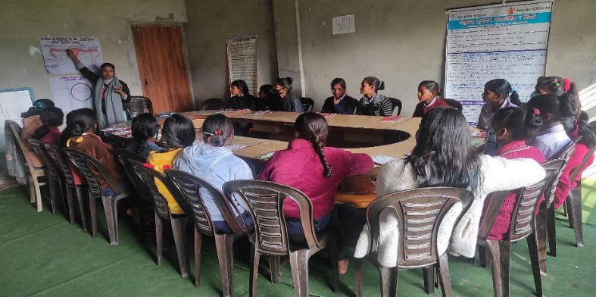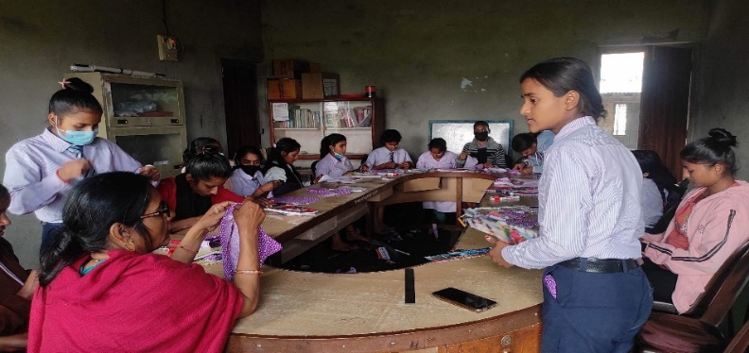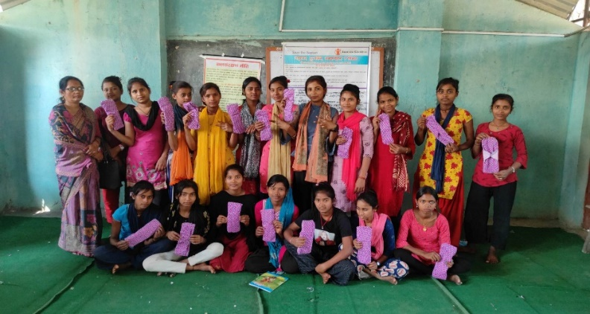
DEMONSTRATION WITH COMPLETION
PRACTICAL SESSION
THEORY SESSION

