SCHOOL HEALTH AND NUTRITION (SHN)WEEK CELEBRATION 2025

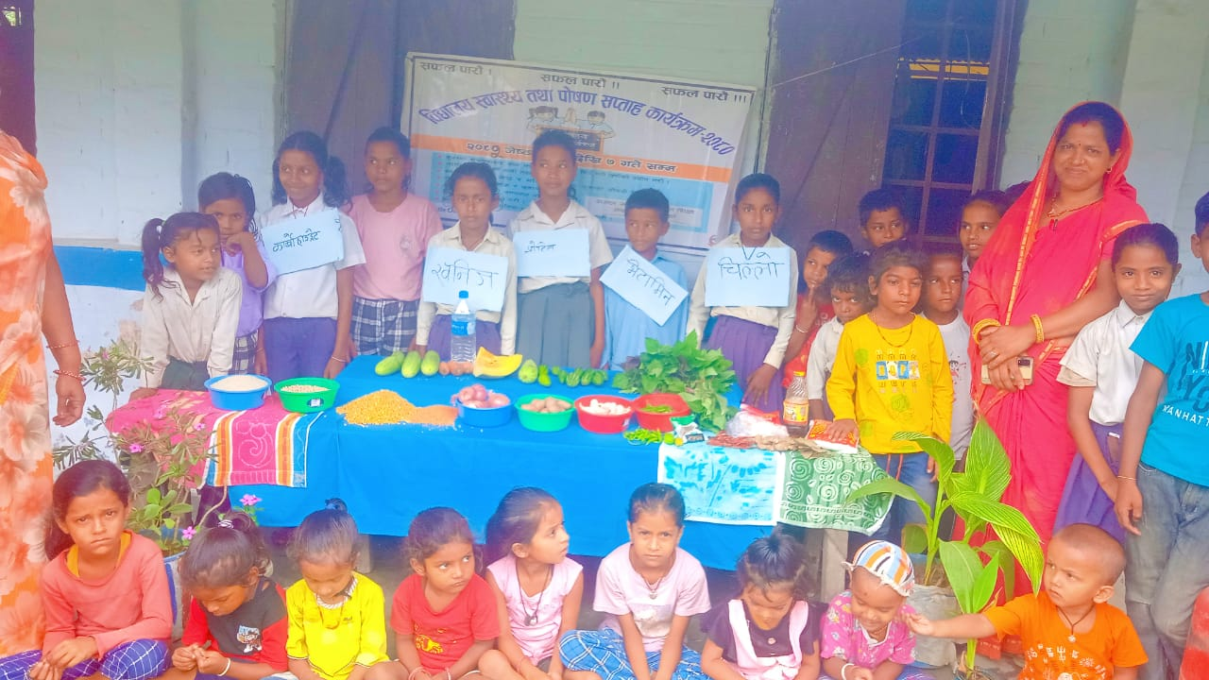
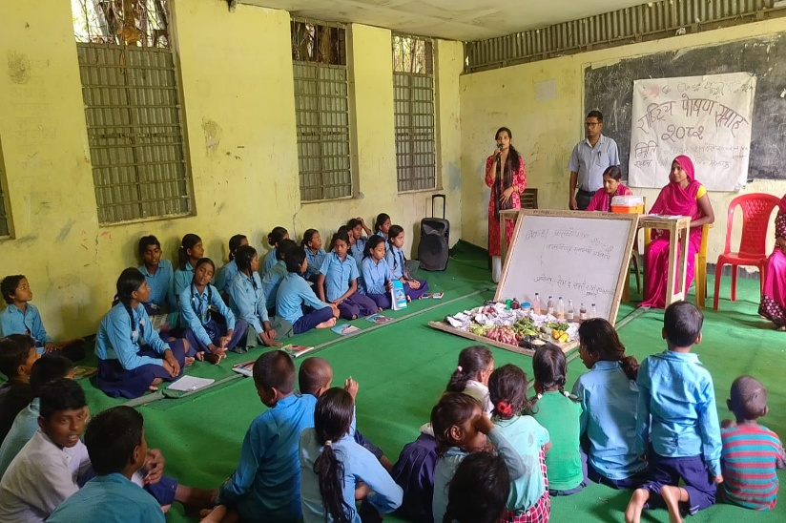
A report on SHN Week Celebration

Title of the Activity: SHN week celebration

Venue: Chinnamasta Rural Municipality (R.M.), Bishnupur R.M, Tilathi Koiladi R.M., & Rajbiraj M. (ward no. 1,5,14,15,16)
Date: 2025/5/15 to 2025/5/21
Schools: All schools of Save the Saptari working area (63 schools)
Participants: - Students, teachers, health post incharge, health coordinator, education officer, community members of working areas.
Supported by: - Save the children & Save the Saptari

Organized by: - Schools & Palikas

Background:

School Health and nutrition program includes all health and nutrition package at school level. Sponsorship funded program (School Health and Nutrition) supports the school children to increase availability of health based in school, improves hygiene and nutrition services, improved quality of school environment, improved knowledge, attitude and interest towards using health services and health preventative& protective behaviors in school and finally improved policy for community support for SHN program implementation. The all above efforts helps children to be healthy which will provide them favorable environment for learning. School Health and Nutrition programs are cost-effective. By addressing all student's special health needs, including prevention and treatment of anemia, providing sanitary facilities and safe drinking water in schools, we are reducing their barriers to learning and increasing their chances to succeed and stay in school.

Objectives
- Raise awareness on malnutrition which is caused due to lack of nutritional diet.
- Raise awareness among community member regarding the importance of nutrition & also effects of malnutrition on development of children.
- Awareness raising on worm infestation and anemia among school going children.
- Improve the health and nutrition status of school children which leads to improve school performance.
- Create a safe & healthy school environment.

Daily Details of the celebration

First Day
- Nutrition demonstration:
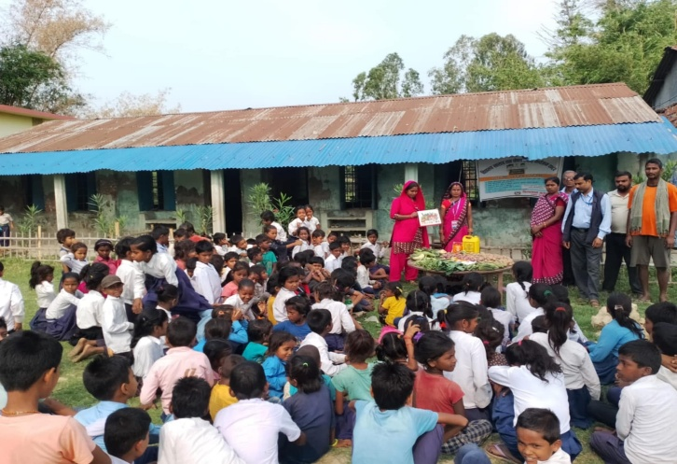
- Teachers & students of school brought demonstration items to schools for nutrition demonstration activity.
- School teachers, community members, schools' children & parents involved in the demonstration and demonstrated fruits, vegetables, rice, pulses, etc (local resources) and oriented on importunate of our food items in our healthy daily life. (HAREK BAR KHANA CHAR)
- First day, event celebrated in all schools of project working areas. SHN focal teacher & health care service providers of Neary HFs facilitated on nutritional diet with demonstration in front of parents, community members & schools' children.
- SHN focal teacher & health care service providers of Neary HFs of respective schools oriented on nutrition, its importance and negative effects of malnutrition in our life.

Second Day
- Health screening & awareness raising activities
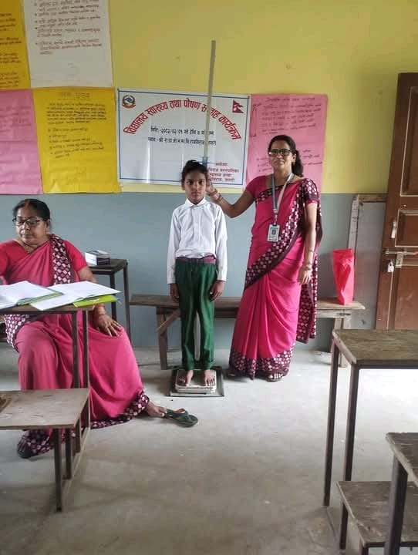
- SHN focal teachers & health care service providers orientated to parents, students & community members on personal hygiene & sanitation, first aid service, child marriage, changes seen in adolescents, menstruation, hand washing, worm infestation, child & maternal nutrition, etc.
- After that, SHN focal teacher & other teachers had screened health (eye checkup, teeth checkup, ht. & wt. measured, ear checkup -listening capacity through whisper test) of all students at their respective schools.
- For this kind of activities save the Saptari supported ht. measuring tool, wt. measuring tool, first aid box & SHN register to all 63 schools before but this year Save the Saptari coordinated with palikas to support this tool to all school so that all focal teacher has done health screening to students regularly. Due to this there haven’t seen any problem during health screening.

Third & fourth Day
- Distribution of deworming tablet to students:
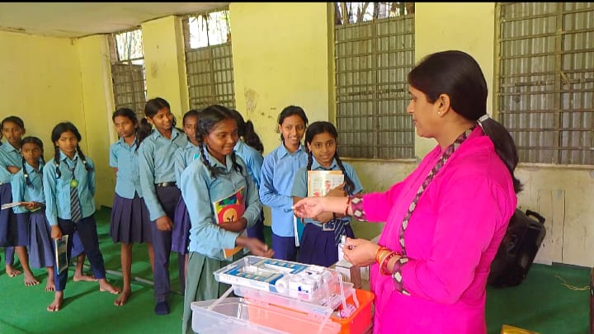
On third- & fourth-day deworming tablet had distributed to all students to keep
- students free from worm infestation and healthy so that they can continue their regular study for better learning performance.
- Some private schools also celebrated SHN week celebration by distributing albendazole tablets.

Fifth Day
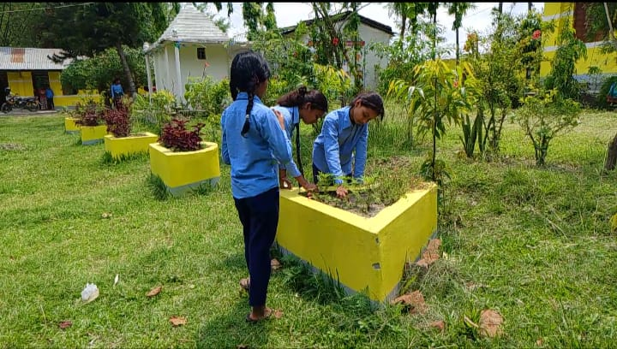
- Sanitation Program:
- On fifth day, Save the Saptari (STS) staffs & school teachers oriented to students & community members on importance of sanitation & cleanliness, climate change with importance of plantation and negative impacts of it.
- Students, Community members & teachers cleaned the classroom & surrounding of schools then planted different types of plants including herbs, flowers, etc.

Sixth Day
- Extra Activities (Quiz)
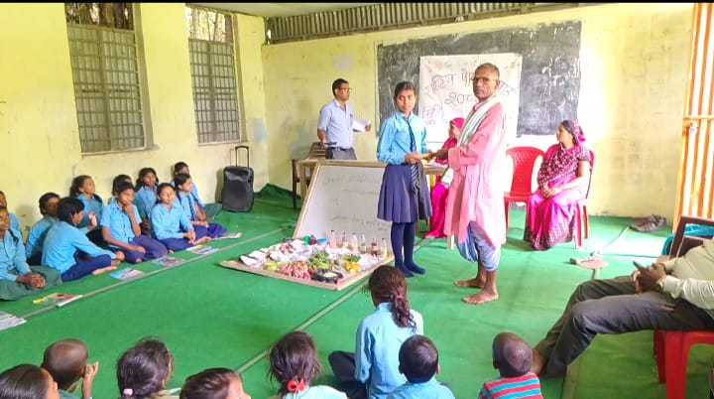
- On sixth day, all schools of working areas conducted different activities (like quiz program, essay competition, drawing competition, dance competition, song competition, etc) in their school. The quiz contents covered questions regarding School, health, nutrition child marriage, sanitation & hygiene & essay competition regarding child marriage & nutrition. Some school held rallies on health & nutrition.
- To conduct the competition, school & ward chairperson has supported or distributed the prize for winner of the competition.
- On this day we collected feedback from students, teachers & community members on SHN week celebration. Some feedback (Participants views) are as follows: -
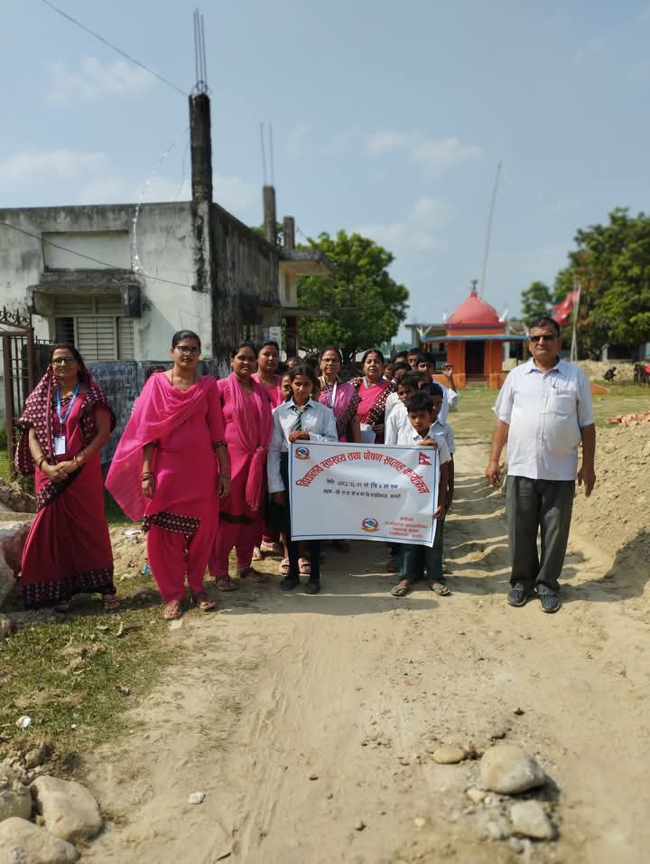
- SHN week celebration program has improved students' knowledge & behavior on health & hygiene practices.
- SHN week celebration program has improved the school environment.
- SHN week celebration has celebrated every year but this year it has celebrated effectively & timely due to the support of STS & palika.
- According to ward chairperson Save the Saptari has a good contribution for their school’s improvement. “I hope positive changes in our school will be seen in the future too” he added. During his closing remarks speech, ward chairperson said “we will continue such kind of campaign jointly in the future too for health and education improvement of our school’s children.
.

Seventh Day
- Review of health and sanitation situation program in school
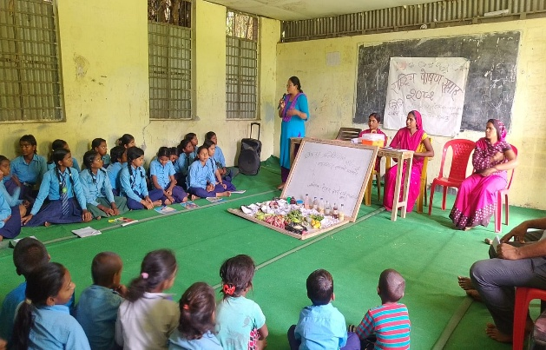
On last day, had a discussion on the SHN campaign which was celebrated recently.
- Team has discussed on, its output, challenges, lesson learning.
- The program implemented so far in the field of school health and nutrition, its effectiveness, the challenges of implementing the program, and how new programs can be implemented more effectively in the coming days.
Challenges
- Very hard to monitor all 63 schools at the same time due to heavy rain in 2nd & 3rd day of activities.
- Due to heavy rain, student's attendance rate at SHN week celebration is low. So, teachers have to spend extra time to those students who have absent while celebration.
- Due to teachers strike, students enrollment campaign became delay so enrollment & SHN week celebration conducted at the same time so its hard for teacher to conduct celebration. So exact data of celebration haven’t found yet.

Learning
- Active involvement of local government in any activity or initiation of local government in program helps to achieve best result.

Output of the Program

Students, teachers & community members oriented on SHN program & its packages.
- Previously, Save the Saptari conducted preparation meeting for SHN week celebration but this year Palikas conducted it in their initiation without our support. Regular coordination with palikas help us to achieve this.
- Previous year nutrition demonstration items & banner for SHN week celebration was distributed by Save the Saptari but this year palikas distributed banner. Demonstration items were managed by teachers & students of school. Also, Chinnamasta Rural municipality provide incentive (rs. 1000) to SHN focal teachers for their contribution in celebration & HP incharge for their monitoring in SHN week celebration.
- More than 99% students had eaten/taken deworming tablet but due to raining season some students had left. Follow up has continue now to ensure that left students will also eat albendazole tablet. When left students will eat albendazole tablets then we again report it.
- 1 to 5 classes students had done health screening by teachers of school.
- In schools’ iron folic tablet had also distributed to adolescent girls.
- Ward chairperson or stakeholders, health coordinator & HP incharge had monitored the celebration.
- Health related session or awareness raising activities were conducted by health care service provider or health coordinator.

Conclusion
- This SHN week celebration was quite beneficial for improving the health &nutrition status of students, teachers & community members. Coordination with local government, stakeholders, health coordinator, education officer, HP incharge regarding SHN week celebration they also managed or distributed albendazole tablets, & iron tablets to all schools of working areas timely. Due to coordination with focal teachers & conduction of quarterly review meeting with SHN focal teachers help or encouraged them to receive deworming tablet timely from Palikas and concerning H.F. As comparing to this year to previous year, previous year, all school did not get albendazole timely & due to this student did not ate albendazole timely but this year students ate timely as SHN week schedule. Due to our (STS) coordination & support all schools of working areas had celebrated SHN week celebration timely & happily also enjoying with fun activity. This SHN week celebration has also build good relation between Stakeholder, STS staffs, teachers, students & community members. All involved members were so happy and requested STS to support always in their community. In this celebration every participant were actively participating and could keep their views without any hindrance. It also reminds the responsibility of chairperson, teachers, students, parents, etc. Fun activity and program motivate students to come school. Program activates the brain of teachers, students and parents.
- Local government & schools are taking initiation to celebrate the SHN week celebration. We (STS) have only supported or coordinated with all schools of our working areas but all celebration or activity has managed or celebrated by local government & schools. By seeing their contribution, we definitely say that they will run such campaign without STS support.

“Thank you”

Prepared and Submitted BY:
Shilpa Deo
Field Officer
Save the Saptari

